Nama : Andri Firman Saputra  
NIM : 201011402125  
Kelas : 05TPLP016  
Tugas : Basis Data II – Latihan 8

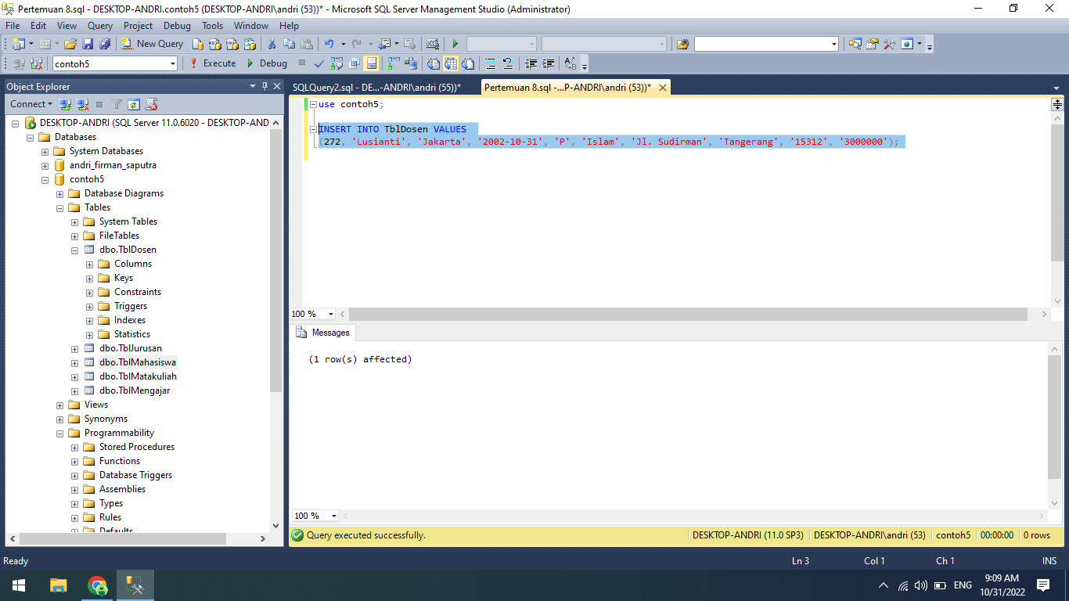

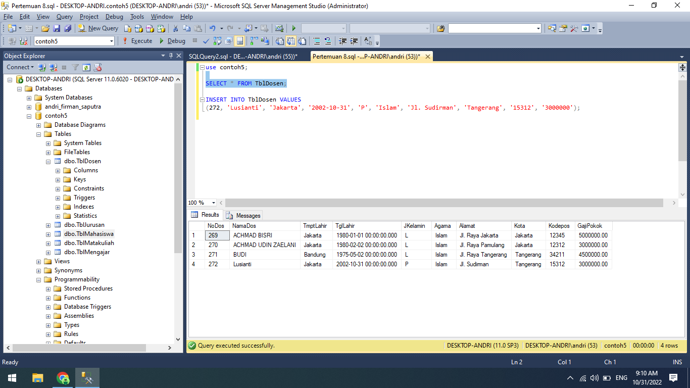

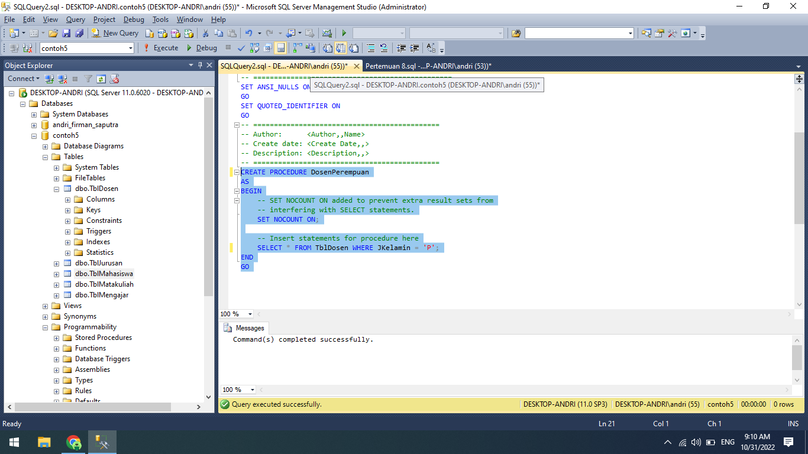

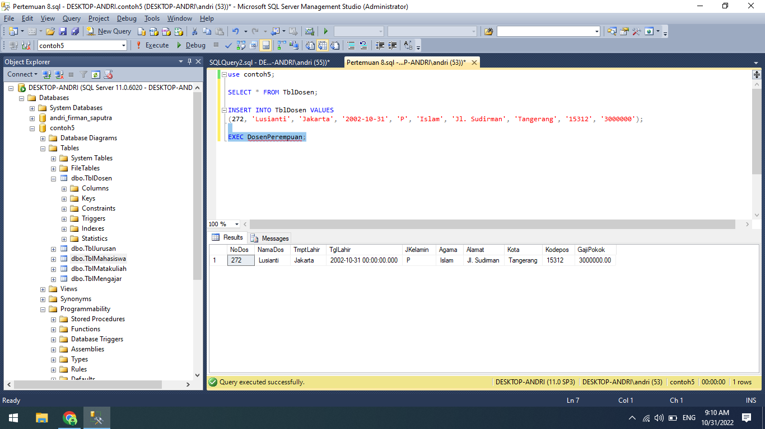

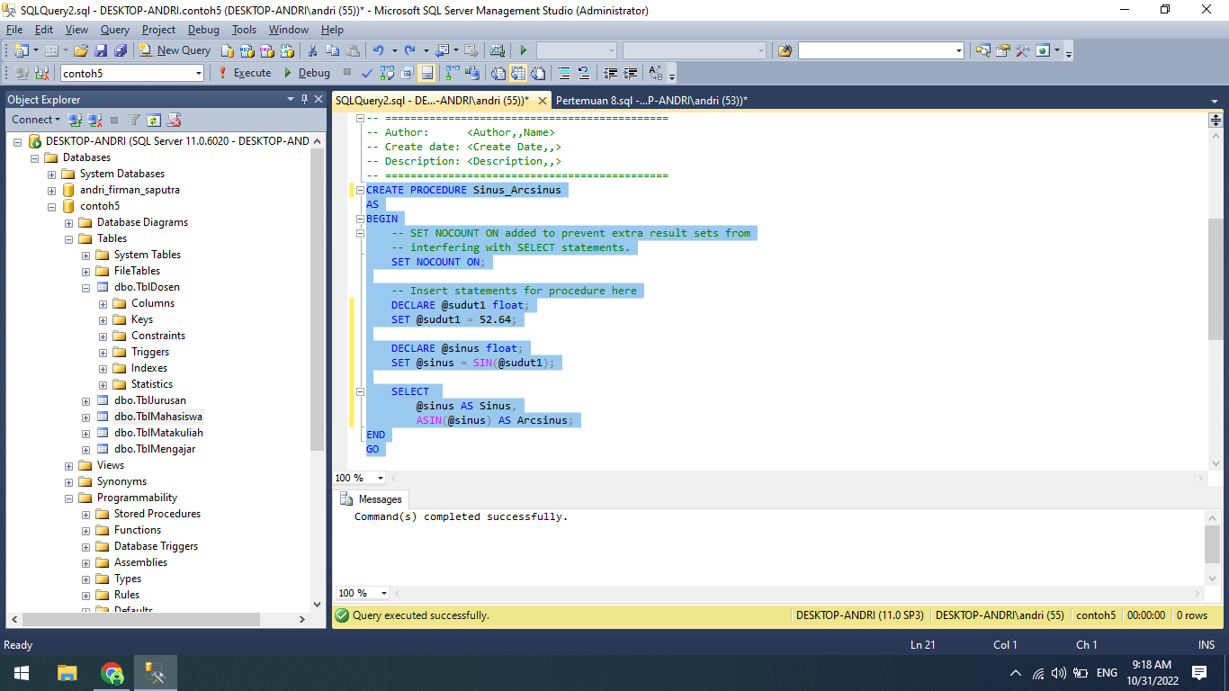

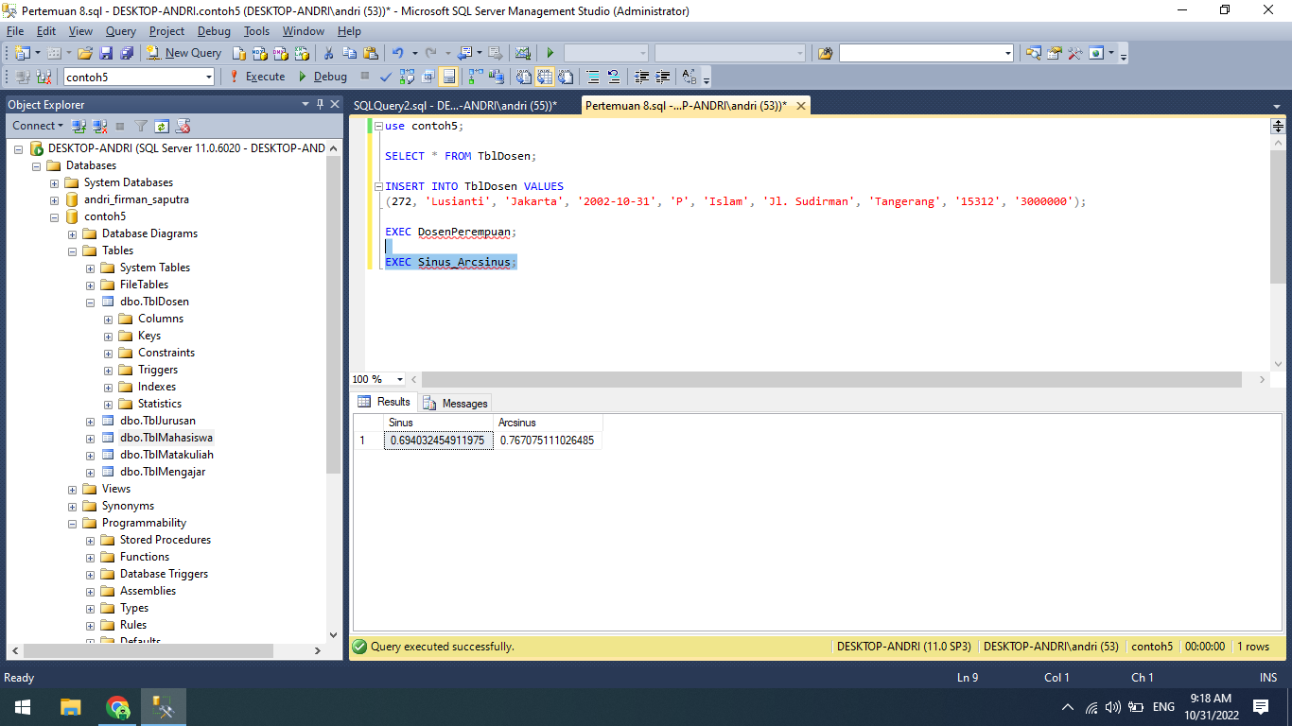

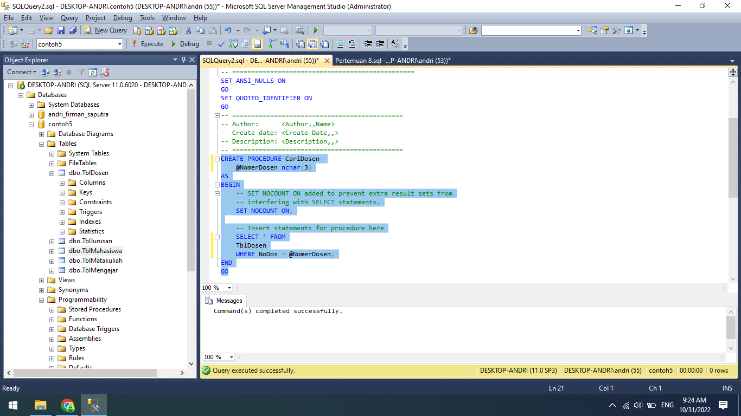

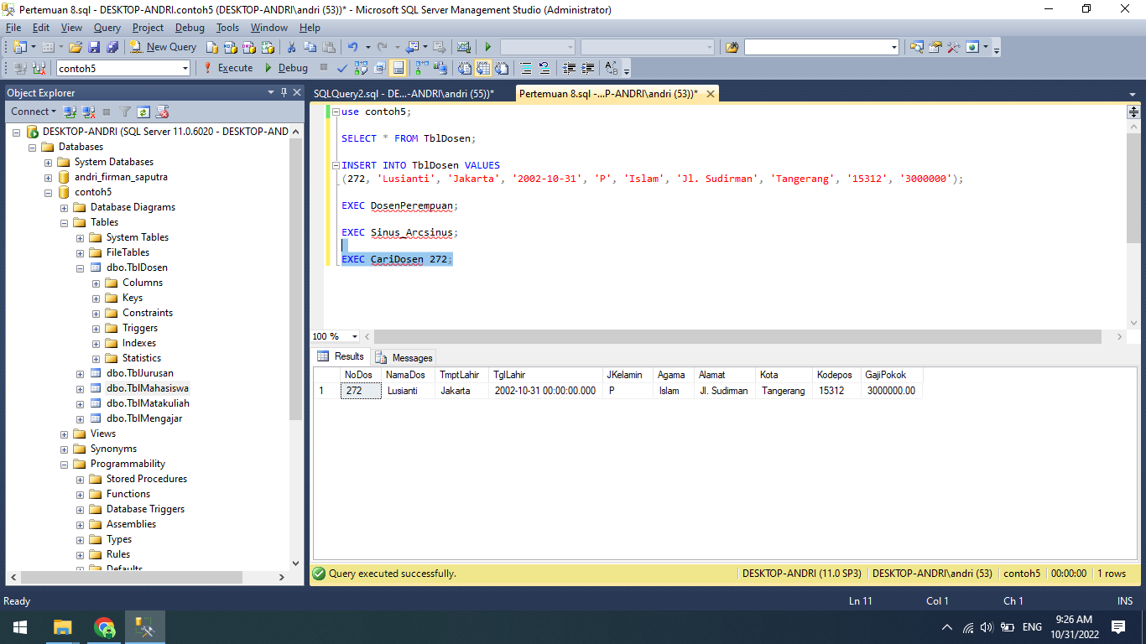

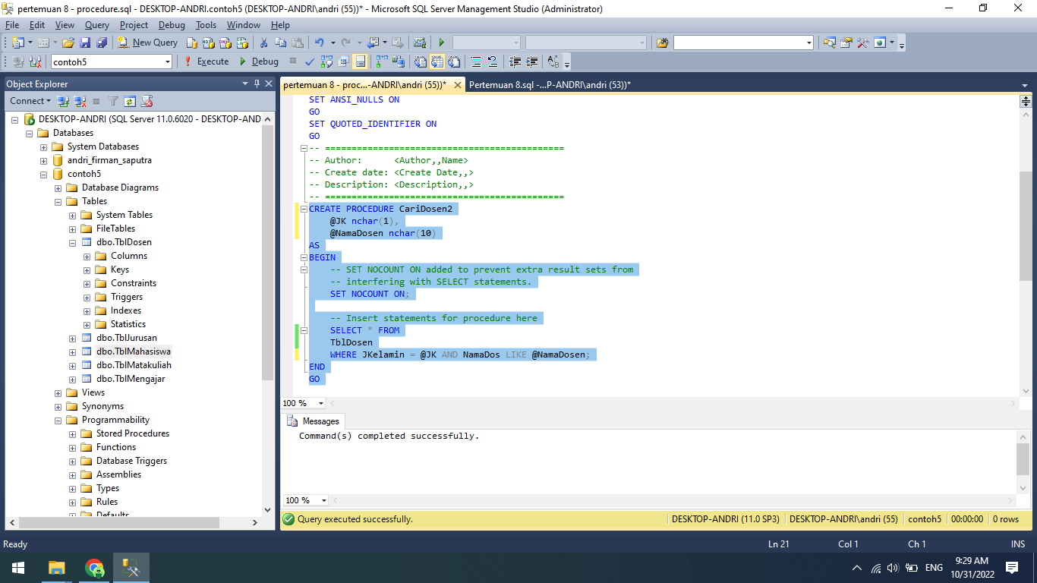

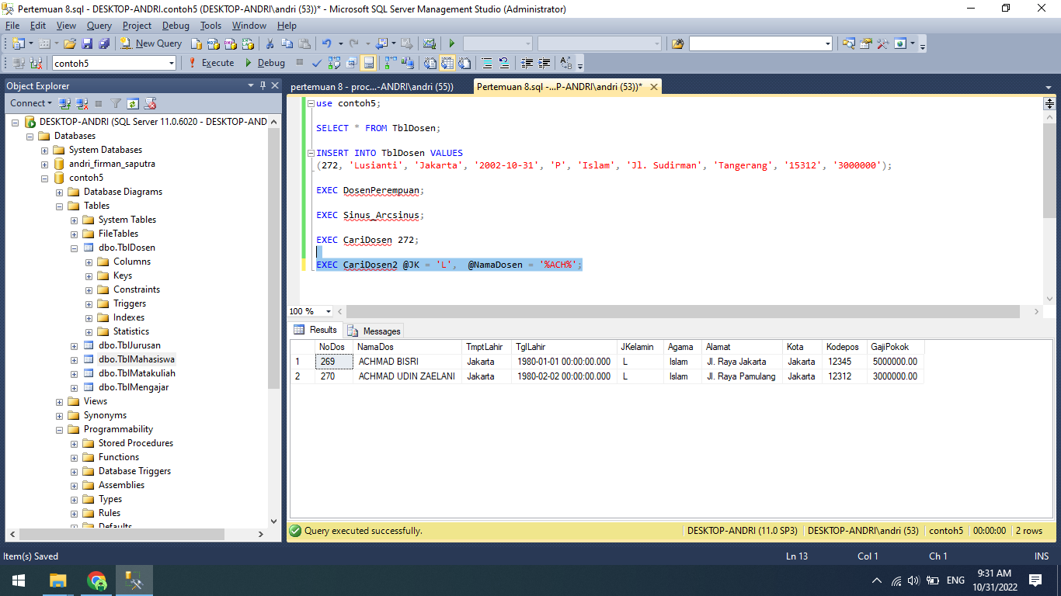

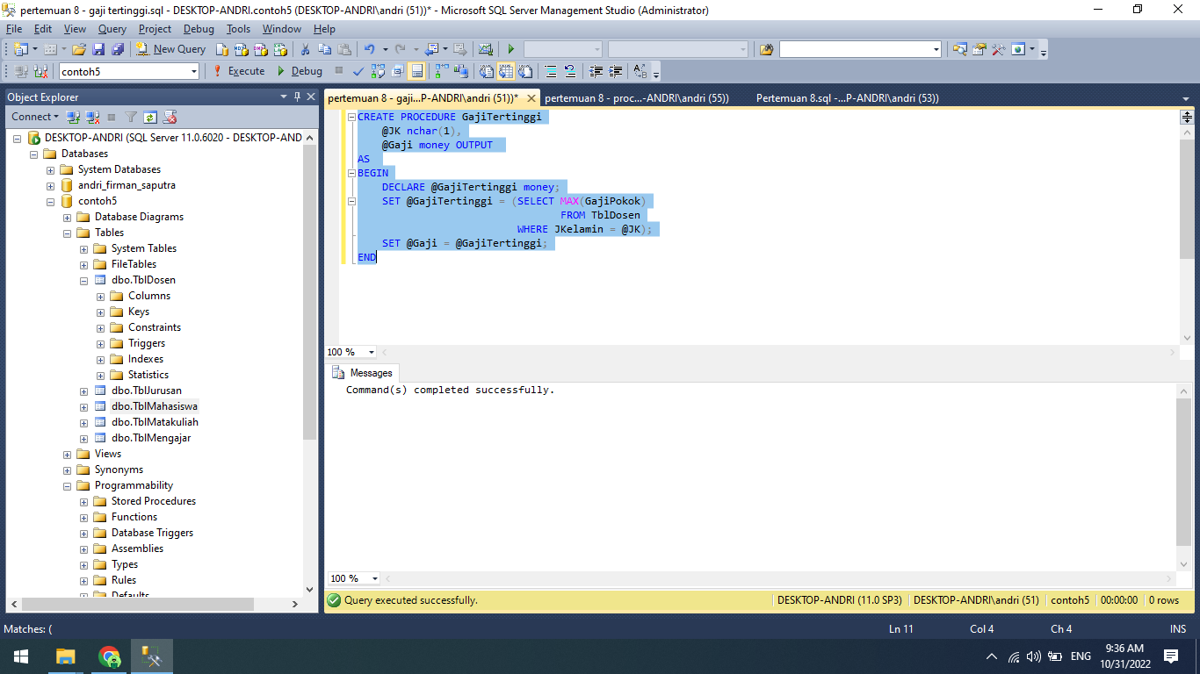

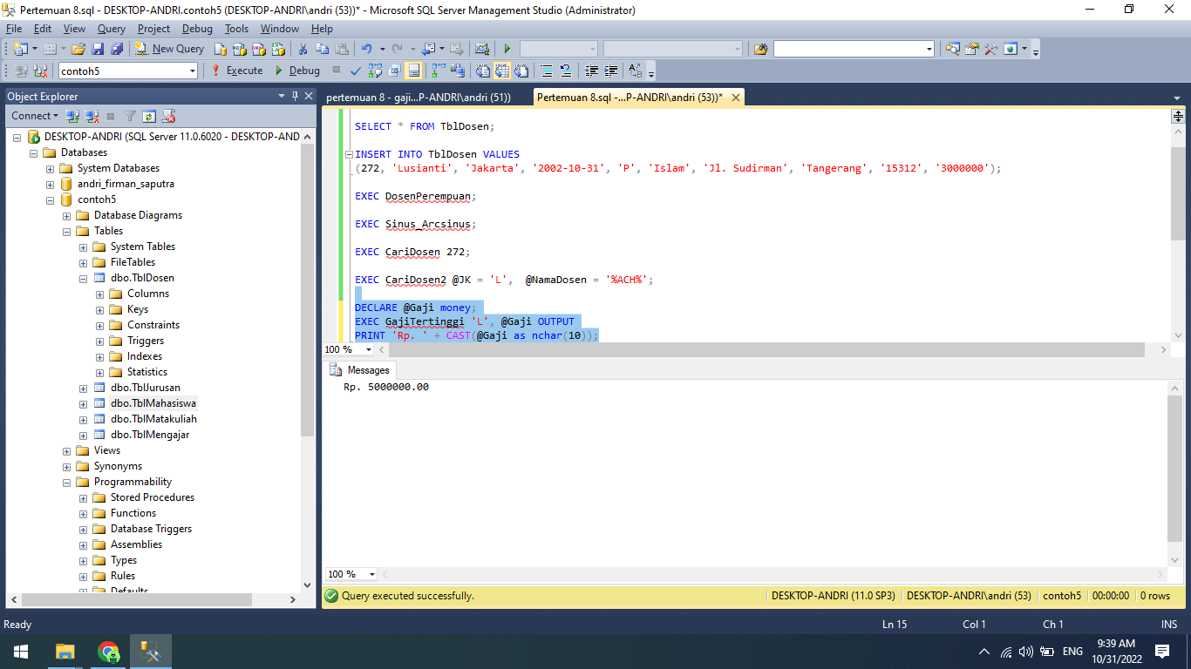

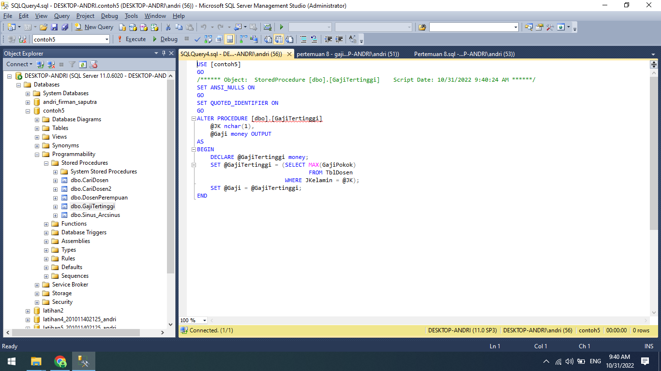

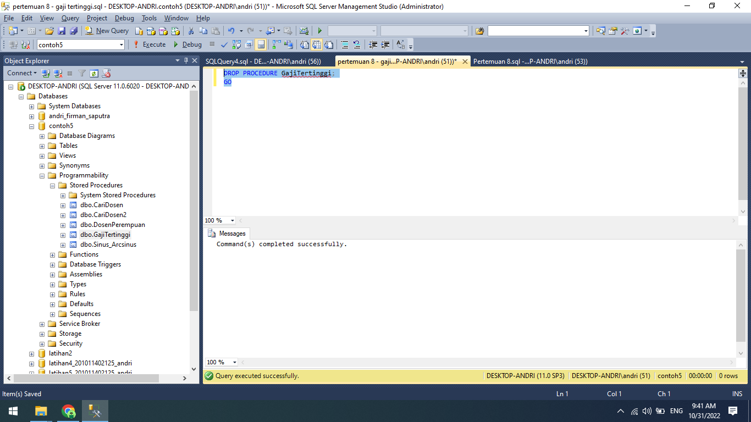

SET ANSI_NULLS ON

GO

SET QUOTED_IDENTIFIER ON

GO

CREATE PROCEDURE DosenPerempuan

AS

BEGIN

SET NOCOUNT ON;

SELECT * FROM TblDosen WHERE JKelamin = 'P';

END

GO

CREATE PROCEDURE Sinus_Arcsinus

AS

BEGIN

SET NOCOUNT ON;

DECLARE @sudut1 float;

SET @sudut1 = 52.64;

DECLARE @sinus float;

SET @sinus = SIN(@sudut1);

SELECT

@sinus AS Sinus,

ASIN(@sinus) AS Arcsinus;

END

GO

CREATE PROCEDURE CariDosen

@NomerDosen nchar(3)

AS

BEGIN

SET NOCOUNT ON;

SELECT * FROM

TblDosen

WHERE NoDos = @NomerDosen;

END

GO

CREATE PROCEDURE CariDosen2

@JK nchar(1),

@NamaDosen nchar(10)

AS

BEGIN

SET NOCOUNT ON;

SELECT * FROM

TblDosen

WHERE JKelamin = @JK AND NamaDos LIKE @NamaDosen;

END

GO

use contoh5;

SELECT * FROM TblDosen;

INSERT INTO TblDosen VALUES

(272, 'Lusianti', 'Jakarta', '2002-10-31', 'P', 'Islam', 'Jl. Sudirman', 'Tangerang', '15312', '3000000');

EXEC DosenPerempuan;

EXEC Sinus_Arcsinus;

EXEC CariDosen 272;

EXEC CariDosen2 @JK = 'L', @NamaDosen = '%ACH%';

DECLARE @Gaji money;

EXEC GajiTertinggi 'L', @Gaji OUTPUT

PRINT 'Rp. ' + CAST(@Gaji as nchar(10));

CREATE PROCEDURE GajiTertinggi

@JK nchar(1),

@Gaji money OUTPUT

AS

BEGIN

DECLARE @GajiTertinggi money;

SET @GajiTertinggi = (SELECT MAX(GajiPokok)

FROM TblDosen

WHERE JKelamin = @JK);

SET @Gaji = @GajiTertinggi;

END

DROP PROCEDURE GajiTertinggi;

GO